**LAPORAN PRAKTIKUM 6**

**Pemograman Berorientasi Obyek**



Disusun Oleh :

M AL FAIZ PUTRA JALASENANDRA (21091397072)

**PROGRAM STUDI D4 MANAJEMEN INFORMATIKA**

**FAKULTAS VOKASI**

**UNIVERSITAS NEGERI SURABAYA**

**2022**

**Source Code**

* **No 1 prak PHP**

<!--- Nama    : M AL FAIZ PUTRA JALASENANDRA

      NIM     : 21091397072

      Kelas   : 2021 B--->

<?php

require_once 'No1 Abstract Prak6.php';

class Truck extends Vehicle {

    public function __construct($maxLoad, $name)

    {

        $this->maxLoad = $maxLoad;

        $this->name = $name;

    }

    public function calcFuelNeeds()

    {

        $fuel = $this->calcFuelEfficiency();

        $trip = $this->calcTripDistance();

        return ceil($fuel /= $trip);

    }

}

class RiverBarge extends Vehicle {

    public function __construct($maxLoad, $name)

    {

        $this->maxLoad = $maxLoad;

        $this->name = $name;

    }

    public function calcFuelNeeds()

    {

        $fuel = $this->calcFuelEfficiency();

        $trip = $this->calcTripDistance();

        return ceil($fuel /= $trip);

    }

}

$truck = new Truck(16000, 'Truk');

$riverBarge = new RiverBarge(15000, 'Perahu');

* **NO 1 Abstract PHP**

<!--- Nama    : M AL FAIZ PUTRA JALASENANDRA

      NIM     : 21091397072

      Kelas   : 2021 B--->

<?php

abstract class Vehicle {

    private $load = 0;

    protected $maxLoad = 0, $name;

    protected function __construct($maxLoad, $name) {

        $this->$maxLoad = $maxLoad;

        $this->$name = $name;

    }

    public function getLoad() {

        return $this->load;

    }

    public function getMaxLoad() {

        echo 'Maksimal muatan ' . $this->name . ' ' ;

        return $this->maxLoad;

    }

    public function addBox($weight) {

        if ($this->load >= $this->maxLoad) {

            echo "$this->name menambah muatan sebesar $weight <br>";

            echo 'Muatan telah penuh tidak bisa menambah lagi';

        }else {

            $this->load += $weight;

            echo "$this->name menambah muatan sebesar $weight";

        }

    }

    abstract public function calcFuelNeeds();

    protected function calcFuelEfficiency() {

        $range = 50000000;

        $range /= $this->load;

        return $range;

    }

    protected function calcTripDistance() {

        return 500;

    }

}

* **NO 1 Index PHP**

<!--- Nama    : M AL FAIZ PUTRA JALASENANDRA

      NIM     : 21091397072

      Kelas   : 2021 B--->

<?php

    require_once 'No1 Prak6.php';

?>

<!DOCTYPE html>

<html lang="id">

<head>

    <!-- Bootstrap CSS -->

    <link href="https://cdn.jsdelivr.net/npm/bootstrap@5.1.3/dist/css/bootstrap.min.css" rel="stylesheet"

    integrity="sha384-1BmE4kWBq78iYhFldvKuhfTAU6auU8tT94WrHftjDbrCEXSU1oBoqyl2QvZ6jIW3" crossorigin="anonymous">

    <title>PBO Praktikum 6</title>

</head>

<body>

    <div class="container">

        <br>

        <h2 class="text-center">PBO - Praktikum 6</h2>

        <div class="row">

            <div class="col-5 mx-auto border p-3 mt-2">

                <h4 class="text-center"><strong>Soal 1</strong></h4>

                <br><br>

                <b><?= $truck->getMaxLoad() . ' kg'; ?> <br></b>

                <br>

                <?= $truck->addBox(1000) . ' kg'; ?> <br>

                <?= $truck->addBox(7000) . ' kg'; ?> <br>

                <?= $truck->addBox(8000) . ' kg'; ?> <br>

                    <?php

                        echo "Jadi, Butuh Bahan Bakar sebanyak " . $truck->calcFuelNeeds() . ' Liter'. '<br>';

                    ?>

                <br>

                ------------------------------------------------

                <br>

                <br>

                <b><?= $riverBarge->getMaxLoad() . ' kg'; ?> <br></b>

                <br>

                <?= $riverBarge->addBox(2000) . ' kg'; ?> <br>

                <?= $riverBarge->addBox(4000) . ' kg'; ?> <br>

                <?= $riverBarge->addBox(9000) . ' kg'; ?> <br>

                    <?php

                        echo "Jadi, Butuh Bahan Bakar sebanyak " . $riverBarge->calcFuelNeeds() . ' Liter';

                    ?>

            </div>

        </div>

    </div>

</body>

</html>

* **HASIL Output**

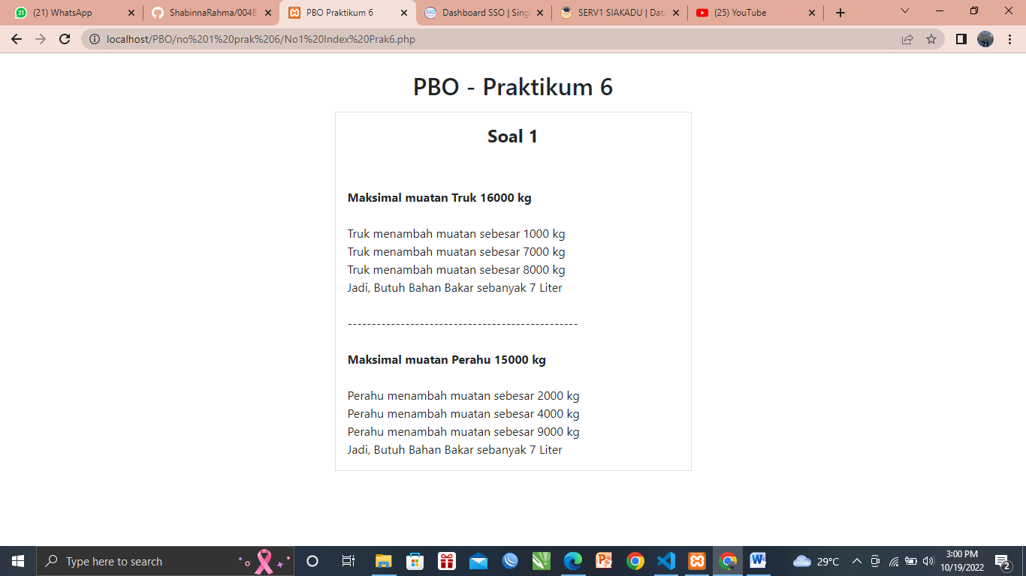

* **PENJELASAN :**

Implementasi dari abstract class pada class Vehicle, method calcFuelNeeds digunakan untuk menghitung bahan bakar yang digunakan. Abstract method di letakkan pada class Vehicle sebagai parent class dan diakses oleh child classnya yaitu class Truk, dan class RiverBarge yang akan mengembalikan nilai yang dihasilkan dari pembagian 2 method yaitu calcFuelEfficiency dan calcTripDistance

**Source Code**

* **NO 2 PRAK PHP**
* <!-- M AL FAIZ PUTRA JALASENANDRA_21091397072 -->
* <?php
* require_once 'interface no2 prak6.php';
* class Airplane implements Flyer {
* public function takeOff() {
* return 'Pesawat lepas landas..';
* }
* public function land() {
* return 'Pesawat mendarat';
* }
* public function fly() {
* return 'Pesawat dalam perjalanan';
* }
* }
* class Bird implements Flyer {
* public function takeOff() {
* return 'Burung mencari makan';
* }
* public function land() {
* return 'Burung kembali pulang';
* }
* public function fly() {
* return 'Burung terbang';
* }
* public function buildNest() {
* return 'Burung membuat sarang';
* }
* public function layEggs() {
* return 'Burung bertelur';
* }
* }
* class Superman implements Flyer {
* public function takeOff() {
* return 'Superman mengejar Batman';
* }
* public function land() {
* return 'Superman melawan Batman';
* }
* public function fly() {
* return 'Superman melancarkan pukulan';
* }
* public function leapBuilding() {
* return 'Batman terpental menabrak bangunan pencakar langit';
* }
* public function stopBullet() {
* return 'Polisi menembaki superman namun ditangkis';
* }
* }
* $airplane = new Airplane;
* $bird = new Bird;
* $superman = new Superman;
* **NO 2 Interface PHP**
* <!-- M AL FAIZ PUTRA JALASENANDRA_21091397072 -->
* <?php
* interface Flyer {
* public function takeOff();
* public function land();
* public function fly();
* }
* interface Sailer {
* public function dock();
* public function cruise();
* }
* **NO 2 Index PHP**

<!-- M AL FAIZ PUTRA JALASENANDRA_21091397072-->

<?php

    require_once 'no 2 prak6.php';

?>

<!DOCTYPE html>

<html lang="en">

<head>

    <!-- Bootstrap CSS -->

    <link href="https://cdn.jsdelivr.net/npm/bootstrap@5.1.3/dist/css/bootstrap.min.css" rel="stylesheet"

    integrity="sha384-1BmE4kWBq78iYhFldvKuhfTAU6auU8tT94WrHftjDbrCEXSU1oBoqyl2QvZ6jIW3" crossorigin="anonymous">

    <title>Praktikum 6</title>

</head>

<body>

    <div class="container">

        <br>

        <div class="row">

            <div class="col-5 mx-auto border p-3 mt-2">

                <h4 class="text-center"><strong><u>Soal 2</u></strong></h4>

                <br><br>

                <b><?php

                        echo "Superman";

                    ?></b> <br>

                <?= $superman->land(); ?> <br>

                <?= $superman->takeOff(); ?> <br>

                <?= $superman->fly(); ?> <br>

                <?= $superman->leapBuilding(); ?> <br>

                <?= $superman->stopBullet(); ?> <br>

                <br>

                <b><?php

                        echo "Bird";

                    ?></b> <br>

                <?= $bird->buildNest(); ?> <br>

                <?= $bird->takeOff(); ?> <br>

                <?= $bird->fly(); ?> <br>

                <?= $bird->land(); ?> <br>

                <?= $bird->layEggs(); ?> <br>

                <br>

                <b><?php

                        echo "Airplane";

                    ?></b> <br>

                <?= $airplane->takeOff(); ?> <br>

                <?= $airplane->fly(); ?> <br>

                <?= $airplane->land(); ?> <br>

            </div>

        </div>

    </div>

</body>

</html>

* **Hasil Output**

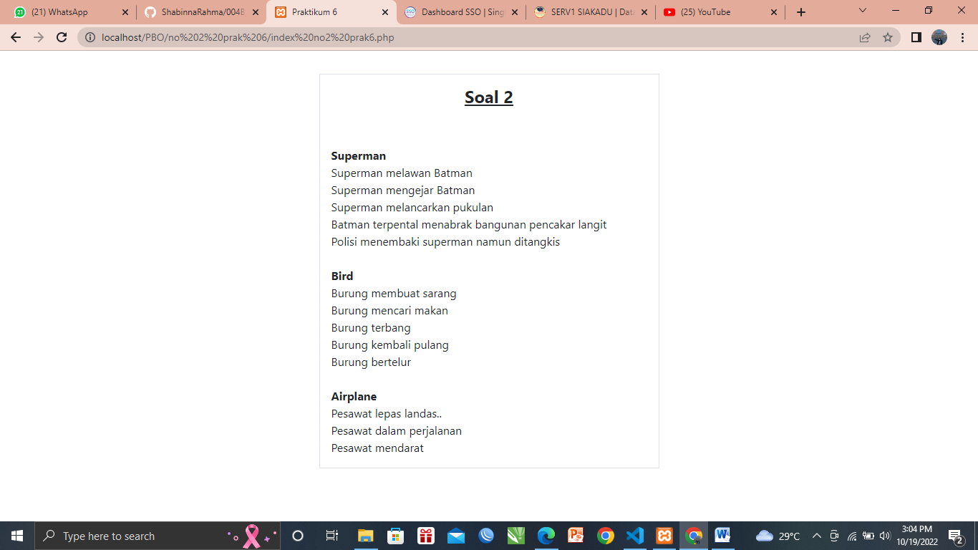

* **Penjelasan :**

Implementasi Polymhorpism dengan penggunaan Interface Flyer sehingga semua class yang Implements dari interface Fyler harus memiliki method takeoff, land, dan fly.

**Source Code**

* **NO 3 Interface PHP**
* <!-- M AL FAIZ PUTRA JALASENANDRA_21091397072 -->
* <?php
* interface Flyer {
* public function takeOff();
* public function land();
* public function fly();
* }
* interface Sailer {
* public function dock();
* public function cruise();
* }
* **NO 3 PRAK PHP**

<!-- M AL FAIZ PUTRA JALASENANDRA_21091397072 -->

<?php

require_once 'abstrac no 3 prak6.php';

require_once 'interface no 3 prak6.php';

class Animal

{

    protected $name;

    public function __construct($name)

    {

        $this->name = $name;

    }

    public function eat()

    {

        return $this->name . ' sedang makan';

    }

}

class Homosapiens extends Animal {}

class Airplane2 extends Vehicle implements Flyer

{

    public function __construct($maxLoad, $name)

    {

        $this->maxLoad = $maxLoad;

        $this->name = $name;

    }

    public function takeOff()

    {

        return "$this->name lepas landas";

    }

    public function land()

    {

        return "$this->name mendarat";

    }

    public function fly()

    {

        return "$this->name dalam perjalanan";

    }

    public function calcFuelNeeds()

    {

        $fuel = $this->calcFuelEfficiency();

        $trip = $this->calcTripDistance();

        return ceil($fuel /= $trip);

    }

}

class Superman2 extends Homosapiens implements Flyer

{

    public function takeOff()

    {

        return "$this->name mengejar Batman";

    }

    public function land()

    {

        return "$this->name melawan Batman";

    }

    public function fly()

    {

        return "$this->name melancarkan pukulan";

    }

    public function leapBuilding()

    {

        return "Batman terpental menabrak bangunan pencakar langit";

    }

    public function stopBullet()

    {

        return "Polisi menembaki $this->name namun ditangkis";

    }

}

$burung = new Animal('Burung');

$manusia = new Homosapiens('Aransha');

$airplane2 = new Airplane2(25000, 'Batik Air');

$superman2 = new Superman2('Superman');

* **NO 3 Abstract PHP**

<!-- M AL FAIZ PUTRA JALASENANDRA_21091397072 -->

<?php

abstract class Vehicle {

    private $load = 0;

    protected $maxLoad = 0, $name;

    protected function __construct($maxLoad, $name) {

        $this->$maxLoad = $maxLoad;

        $this->$name = $name;

    }

    public function getLoad() {

        return $this->load;

    }

    public function getMaxLoad() {

        echo 'Maksimal muatan ' . $this->name . ' ' ;

        return $this->maxLoad;

    }

    public function addBox($weight) {

        if ($this->load >= $this->maxLoad) {

            echo "$this->name menambah muatan sebesar $weight <br>";

            echo 'Muatan telah penuh tidak bisa menambah lagi';

        }else {

            $this->load += $weight;

            echo "$this->name menambah muatan sebesar $weight";

        }

    }

    abstract public function calcFuelNeeds();

    protected function calcFuelEfficiency() {

        $range = 50000000;

        $range /= $this->load;

        return $range;

    }

    protected function calcTripDistance() {

        return 500;

    }

}

* **NO 3 Index PHP**

<!-- M AL FAIZ PUTRA JALASENANDRA_21091397072 -->

<?php

    require_once 'no 3 prak6.php';

?>

<!DOCTYPE html>

<html lang="id">

<head>

    <!-- Bootstrap CSS -->

    <link href="https://cdn.jsdelivr.net/npm/bootstrap@5.1.3/dist/css/bootstrap.min.css" rel="stylesheet"

    integrity="sha384-1BmE4kWBq78iYhFldvKuhfTAU6auU8tT94WrHftjDbrCEXSU1oBoqyl2QvZ6jIW3" crossorigin="anonymous">

    <title>Praktikum 6</title>

</head>

<body>

    <div class="container">

        <div class="row">

            <div class="col-5 mx-auto border p-3 mt-2">

                <h4 class="text-center"><strong><u>Soal 3</u></strong></h4>

                <br><br>

                <?= $burung->eat(); ?> <br>

                <?= $manusia->eat(); ?> <br>

                <br>

                <b><?= $airplane2->getMaxLoad() . ' kg'; ?> <br></b>

                <?= $airplane2->addBox(6000) . ' kg'; ?> <br>

                <?= $airplane2->addBox(2000) . ' kg'; ?> <br>

                <?= $airplane2->addBox(7000) . ' kg'; ?> <br>

                <?= $airplane2->addBox(5000) . ' kg'; ?> <br>

                <?= $airplane2->takeOff(); ?> <br>

                <?= $airplane2->fly(); ?> <br>

                <?= $airplane2->land(); ?> <br>

                <?php

                        echo "Jadi, Butuh Bahan Bakar sebanyak " . $airplane2->calcFuelNeeds() . ' Liter'. '<br>';

                    ?>

                <br>

                <?= $superman2->eat(); ?> <br>

                <?= $superman2->land(); ?> <br>

                <?= $superman2->takeOff(); ?> <br>

                <?= $superman2->fly(); ?> <br>

                <?= $superman2->leapBuilding(); ?> <br>

                <?= $superman2->stopBullet(); ?> <br>

            </div>

        </div>

    </div>

</body>

</html>

* **HASIL Output**

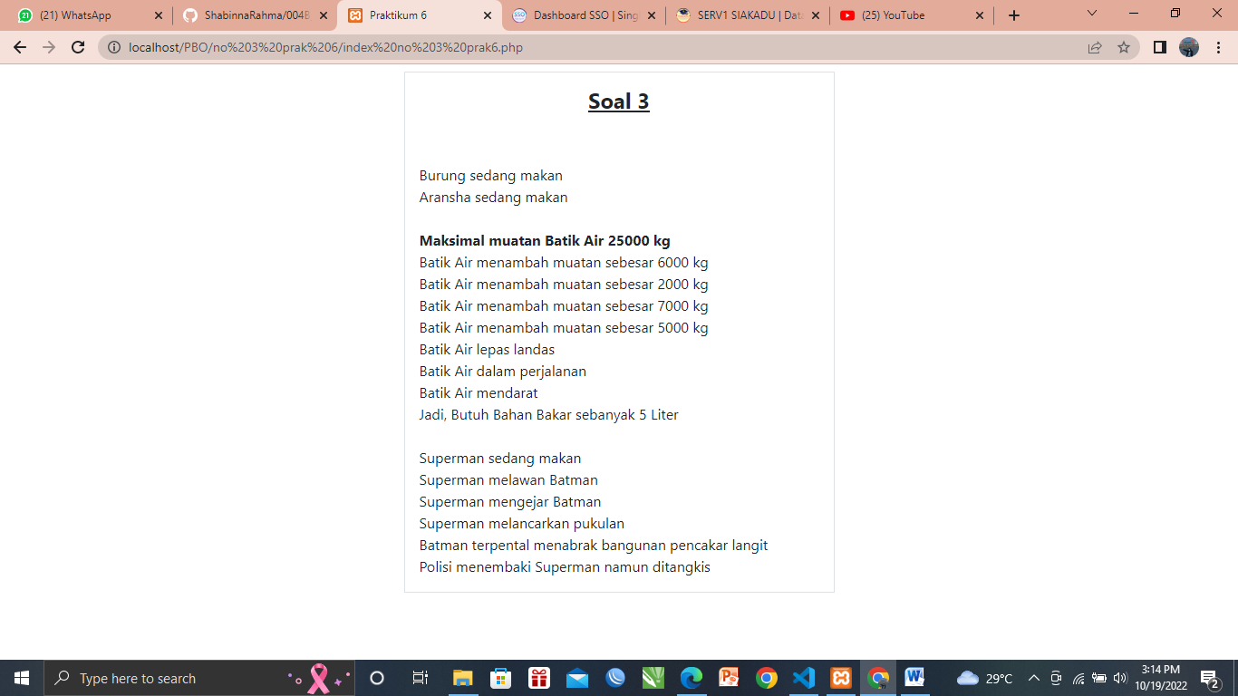

* **Analisa**

Terdapat interface Flyer dan abtract class Vehicle. Class airplane implementasi dari interface Flyer dan turunan dari Vehicle sehingga class Airplane harus memiliki method calcFuelNeeds, takeoff, land, dan fly. Class Bird implementasi dari Flyer dan turunan dari Animal sehingga memiliki method takeoff, land, fly, dan eat. Class Superman turunan dari homosapiens yang juga turunan dari Animal, serta implementasi dari interface Flyer. Maka class Superman memiliki method eat, takeoff, land, fly.

**Source Code**

* **NO 4 Interface PHP**
* <!--- Nama    : M AL FAIZ PUTRA JALASENANDRA
* NIM     : 21091397072
* Kelas   : 2021 b--->
* <?php
* interface Flyer {
* public function takeOff();
* public function land();
* public function fly();
* }
* interface Sailer {
* public function dock();
* public function cruise();
* }
* **NO 4 PRAK PHP**
* <!--- Nama    : M AL FAIZ PUTRA JALASENANDRA
* NIM     : 21091397072
* Kelas   : 2021 B--->
* <?php
* require_once 'No4 Abstract Prak6.php';
* require_once 'No4 interface prak6.php';
* class RiverBarge2 extends Vehicle implements Sailer {
* public function __construct($maxLoad, $name) {
* $this->maxLoad = $maxLoad;
* $this->name = $name;
* }
* public function calcFuelNeeds() {
* $fuel = $this->calcFuelEfficiency();
* $trip = $this->calcTripDistance();
* return ceil($fuel /= $trip);
* }
* public function dock() {
* return $this->name . ' berada di dermaga';
* }
* public function cruise() {
* return $this->name . ' sedang berlayar';
* }
* }
* class Airplane2 implements Flyer {
* public function takeOff() {
* return 'Pesawat lepas landas';
* }
* public function land() {
* return 'Pesawat mendarat';
* }
* public function fly() {
* return 'Pesawat dalam perjalanan';
* }
* }
* class SeaPlane extends Vehicle implements Sailer {
* public function __construct($maxLoad, $name) {
* $this->maxLoad = $maxLoad;
* $this->name = $name;
* }
* public function calcFuelNeeds() {
* $fuel = $this->calcFuelEfficiency();
* $trip = $this->calcTripDistance();
* return ceil($fuel /= $trip);
* }
* public function dock() {
* return $this->name . ' berada di dermaga';
* }
* public function cruise() {
* return $this->name . ' sedang berlayar';
* }
* public function takeOff() {
* return $this->name . ' lepas landas';
* }
* public function land() {
* return $this->name . ' mendarat';
* }
* public function fly() {
* return $this->name . ' dalam perjalanan';
* }
* }
* class Helicopter extends Vehicle {
* public function __construct($maxLoad, $name) {
* $this->maxLoad = $maxLoad;
* $this->name = $name;
* }
* public function calcFuelNeeds() {
* $fuel = $this->calcFuelEfficiency();
* $trip = $this->calcTripDistance();
* return ceil($fuel /= $trip);
* }
* public function takeOff() {
* return $this->name . ' lepas landas';
* }
* public function land() {
* return $this->name . ' mendarat';
* }
* public function fly() {
* return $this->name . ' dalam perjalanan';
* }
* }
* $riverBarge2 = new RiverBarge2(30000, 'Atomic');
* $seaPlane = new SeaPlane(20000, 'Titanic');
* $helicopter = new Helicopter(10000, 'Brocklyn');

* **NO 4 Abstract PHP**

<!--- Nama    : M AL FAIZ PUTRA JALASENANDRA

      NIM     : 21091397072

      Kelas   : 2021 B--->

<?php

abstract class Vehicle {

    private $load = 0;

    protected $maxLoad = 0, $name;

    protected function __construct($maxLoad, $name) {

        $this->$maxLoad = $maxLoad;

        $this->$name = $name;

    }

    public function getLoad() {

        return $this->load;

    }

    public function getMaxLoad() {

        echo 'Maksimal muatan ' . $this->name . ' ' ;

        return $this->maxLoad;

    }

    public function addBox($weight) {

        if ($this->load >= $this->maxLoad) {

            echo "$this->name menambah muatan sebesar $weight <br>";

            echo 'Muatan telah penuh tidak bisa menambah lagi';

        }else {

            $this->load += $weight;

            echo "$this->name menambah muatan sebesar $weight";

        }

    }

    abstract public function calcFuelNeeds();

    protected function calcFuelEfficiency() {

        $range = 50000000;

        $range /= $this->load;

        return $range;

    }

    protected function calcTripDistance() {

        return 500;

    }

}

* **NO 4 Index PHP**
* <!--- Nama    : M AL FAIZ PUTRA JALASENANDRA
* NIM     : 21091397072
* Kelas   : 2021 B--->
* <?php
* require_once 'No4 prak6.php';
* ?>
* <!DOCTYPE html>
* <html lang="en">
* <head>
* <!-- Bootstrap CSS -->
* <link href="https://cdn.jsdelivr.net/npm/bootstrap@5.1.3/dist/css/bootstrap.min.css" rel="stylesheet"
* integrity="sha384-1BmE4kWBq78iYhFldvKuhfTAU6auU8tT94WrHftjDbrCEXSU1oBoqyl2QvZ6jIW3" crossorigin="anonymous">
* <title>PBO - Praktikum 6</title>
* </head>
* <body>
* <h2 class="text-center">PBO - Praktikum 6</h2>
* <div class="container">
* <div class="row">
* <h4 class="text-center"><strong>Soal 4</strong></h4>
* <br><br>
* <div class="col-4 mx-auto border p-2 mt-2">
* <b><?= $riverBarge2->getMaxLoad() . ' kg'; ?> <br></b>
* <?= $riverBarge2->addBox(12000) . ' kg'; ?> <br>
* <?= $riverBarge2->addBox(14000) . ' kg'; ?> <br>
* <?= $riverBarge2->addBox(1000) . ' kg'; ?> <br>
* <?= $riverBarge2->addBox(3000) . ' kg'; ?> <br>
* <?= $riverBarge2->dock(); ?> <br>
* <?= $riverBarge2->cruise(); ?> <br>
* <?php
* echo "Jadi, Butuh Bahan Bakar sebanyak " . $riverBarge2->calcFuelNeeds() . ' Liter'. '<br>';
* ?>
* </div>
* <div class="col-4 mx-auto border p-2 mt-2">
* <b><?= $seaPlane->getMaxLoad() . ' kg'; ?> <br></b>
* <?= $seaPlane->addBox(12000) . ' kg'; ?> <br>
* <?= $seaPlane->addBox(8000) . ' kg'; ?> <br>
* <?= $seaPlane->dock(); ?> <br>
* <?= $seaPlane->cruise(); ?> <br>
* <?= $seaPlane->takeOff(); ?> <br>
* <?= $seaPlane->fly(); ?> <br>
* <?= $seaPlane->land(); ?> <br>
* <?php
* echo "Jadi, Butuh Bahan Bakar sebanyak " . $seaPlane->calcFuelNeeds() . ' Liter'. '<br>';
* ?>
* </div>
* <div class="col mx-auto border p-2 mt-2">
* <b><?= $helicopter->getMaxLoad() . ' kg'; ?> <br></b>
* <?= $helicopter->addBox(8000) . ' kg'; ?> <br>
* <?= $helicopter->addBox(2000) . ' kg'; ?> <br>
* <?= $helicopter->takeOff(); ?> <br>
* <?= $helicopter->fly(); ?> <br>
* <?= $helicopter->land(); ?> <br>
* <?php
* echo "Jadi, Butuh Bahan Bakar sebanyak " . $helicopter->calcFuelNeeds() . ' Liter'. '<br>';
* ?>
* </div>
* </div>
* </div>
* </body>
* </html>
* **HASIL Output**

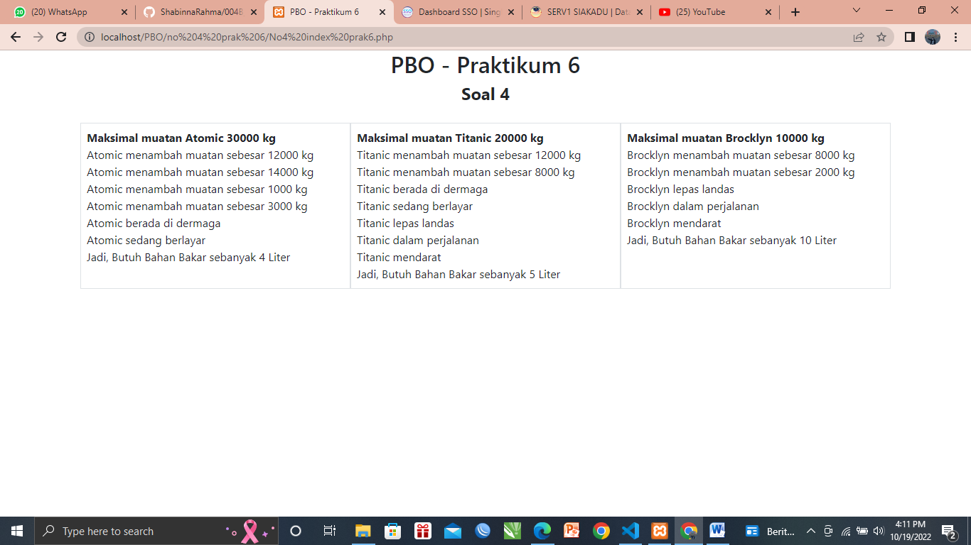

* **Analisa**

Implementasi polymhorphism dengan interface dan abstact class detinjukkan pada class SeaPlane yang implements interface Sailer, turunan dari class Airplane yang implements Flyer dan child dari Vehicle sehingga class SeaPlane memiliki method dock, cruise, takeoff, land, fly, dan calcFuelNeeds